Charts and Graphs , Cool Infographics & Data Visualizations - 0 comments
If you want to tell the story of how your business / project / charity / thing is going on, then making a dashboard is the best way to go about it. Dashboards can combine heaps of data, insights and messages in to one concise format that fits on to a desktop or table or mobile screen.
But let’s be honest. Creating them in Excel is a lot of work. Even after spending hours on them, they might still look meh. So, let me share a trick to make your dashboards look snazzy (without compromising on insights per inch).
Create dashboard tiles, something like this:
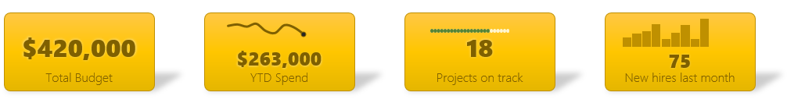

How to create Excel dashboard tiles
Here is a step-by-step process to create dashboard tiles.

1. Calculate necessary numbers and place them in cells
This is simple. Let’s say you want to make a “Total Budget” tile, that reads
Total Budget
$420,500
Let’s assume the number 420,500 is in cell C11.

2. Use TEXT formula to convert numbers to the format you want
If you have a number in cell, you can easily format it any way you want. Since we will be using Text boxes and drawing shapes to show numbers on the dashboard tiles, we will not be able to format them using number format options. Hence we will use TEXT formula to turn a simple number 420500 to $420,500.
=TEXT(C11, "$#,##")
Here are a few TEXT formula examples you can use:
Format you want | Input | TEXT formula | Output
Currency format | 420500 | =TEXT(A1, “$#,##”) | $420,500
Currency with cents | 420500.75 | =TEXT(A1, “$#,##.00”) | $420,500.75
Percentages | 0.7453 | =TEXT(A1,”0%”) | 75%
Percentage with 2 decimal points | 0.7453 | =TEXT(A1,”0.00%”) | 74.53%
Learn more about TEXT formula and format options.

3. Create a tile using drawing shapes in Insert ribbon
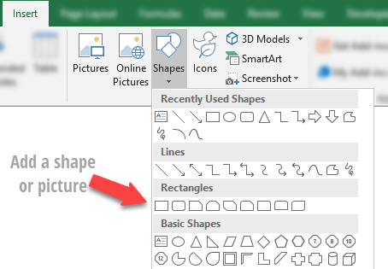
Time to let your creative juices flow. Head over to insert ribbon and add a drawing shape (or even an image) to create a tile. Here are few examples if you need inspiration.


4. Title the tile tastefully
Now that we have a living breathing tile, name it. Just right click on it and “Edit text” to add a tile. Format it to suit rest of your dashboard theme / fonts. Make sure your title is aligned at bottom or top, as we want rest of the space for actual number. This is how your tile should look at the end.
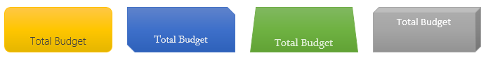

5. Create a text box and link TEXT() output cell to it
Use Insert ribbon and add a text box. Now select the text box and click on formula bar and point to the cell that contains the tile value. See this quick screencast to understand how to do it.


6. Format text box
This is the secret part. You can format linked text boxes! So select it and use format options (fonts, sizes, shadows etc.) to format it.


7. Overlay text box on top of tile
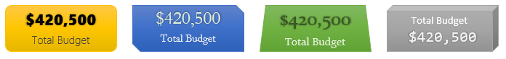
Time to flex your finger muscles. We are in for some serious mouse action here. Just drag and drop the text box on top of dashboard tile. Voila, your Excel dashboard tile is ready. If your calculations change, the tile does too. And it looks sleek. How cool is that.

Few more dashboard tile examples
- 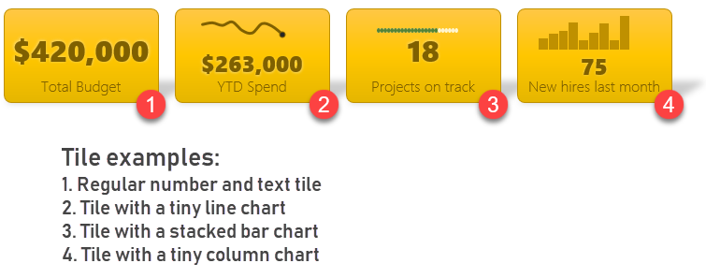
You can use anything on these tiles. Sparklines, tiny charts, conditionally formatting, picture links, photos (really) or more numbers. Just use your creativity and Excel trickery to make these tiles shine. Here are few more examples.

Download Excel Dashboard Tiles – Example workbook
Click here to download Excel dashboard tiles workbook. It has all these tiles, necessary calculations and charts. See the “Making of a tile – steps” to see all the steps for creating such tiles in your workbooks.

Want to make Awesome dashboards? Join Excel School program
If you work in data analysis or reporting roles, dashboard skills are vital for success. This is why I created Excel School program. This in-depth, video-tutorial based course will teach you all the skills needed to create world-class dashboards, like this in just hours.

Example dashboard from Excel School Program
Sales Performance Dashboard
Click here to know more and join Excel School program.

